Jay Nolan Community Services
Strategic Plan
2019 - 2023
Approved by the Board of Directors
November 13, 2018

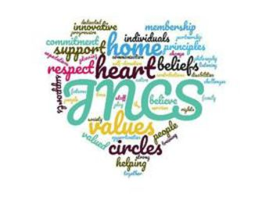

What is a Strategic Plan?

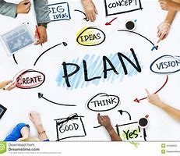

A strategic plan is something an agency uses to help make the programs and services better in the future.

It has things like:
- Ways to serve people better
- New ideas we want to try
- Skills we want to get better at
- Things to help us work together better
- Ways to communicate better
- Ways to help the agency serve more people and more areas
- Things that will make us stronger

How Do We Use the Strategic Plan?

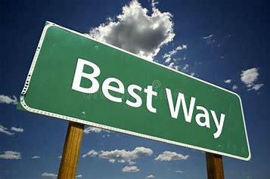

We use the plan to help us figure out how to be a good agency. The senior management staff are the Strategic Plan Team. Each goal is assigned to one or two senior staff who put together a smaller team to work on that goal.

The teams meet regularly to decide how to make the goal successful. They work with other parts of the agency to set up new ways of providing services, so we can meet our goals.

The big Strategic Plan Team meets once a quarter (every three months) to see how the smaller teams are doing on their goals. After this meeting, we present our report to the Board of Directors about the progress on our goals.

At the beginning of each year, we look at the plan to see if we need to make changes in it. We present the plan to the people we support and other people who care about what we do. We listen to them to get their input on the plan.
How Was Our Strategic Plan Developed?

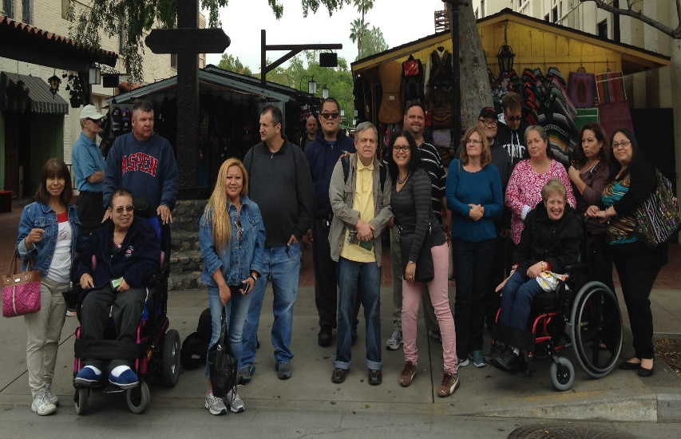

Our plan affects the lives of many people, so we talked to some of those people to see what they think about Jay Nolan Community Services. We asked them several questions:
- What is JNCS doing well?
- What is JNCS not doing very well?
- What would you like to see JNCS doing?
- What advice would you give JNCS to be a better agency?
Here are the groups of people we talked to:
- People with disabilities who use our services
- Families of people we support
- Direct support staff in our programs
- Supervisors of programs
- Senior Management Team and the Executive Director
- JNCS’ Board of Directors
- Online survey participants
We listened to people to see what they like about JNCS and what they want JNCS to be doing. Here’s what people said about what they liked:
What we like about JNCS:
- JNCS has good values and has “heart.”
- JNCS believes people with disabilities have a right to the same kind of life that other people have.
- JNCS believes people should get the support they need to have a life like other people.
- JNCS believes people with disabilities should not be segregated away from other people in the community.
- JNCS treats the people they serve with respect and listens to them.
- JNCS believes each person should have control of their own life.
- JNCS is willing to try new things so that people can live good lives.
- JNCS has good staff who get a lot of training.

We used what people told us to decide on the goals that we want to accomplish in the next five years. The plan runs from January 2019 until December 2023. We will be making reports every year to tell everyone what is happening with the plan.

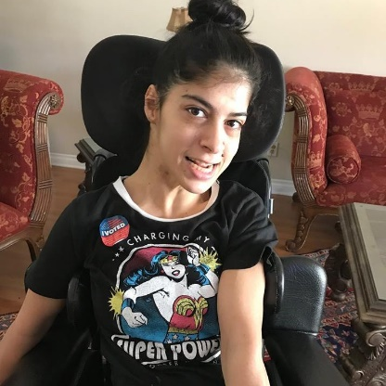
Our Goals

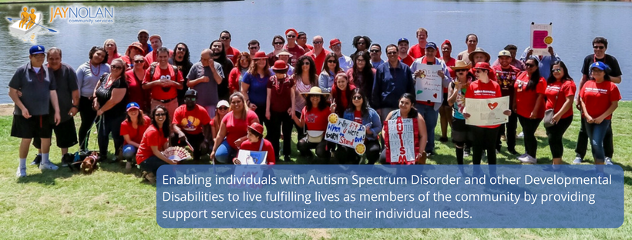

Goal #1: Strengthen our organization’s structure

  - Set up a plan for using computers and other technology well.
  - Make sure we are abiding by all laws and regulations about staff and our organization.
  - Set up a plan for increasing the money we can bring in through fundraising.
  - Make sure we are reporting to people about how we are doing and that we are asking people what they think about JNCS.
  - Make sure we are doing a good job managing our budget.
  - Make sure our Board of Directors is strong and effective.
  - Make sure we are operating the agency the best way we can.

Goal #2: Improve JNCS by working together toward our mission.

- Work together to use our strategic plan every day to guide our agency.
- Improve communication throughout our agency.
- Make sure staff are valued and professional.
- Set up a plan to find and keep good staff.

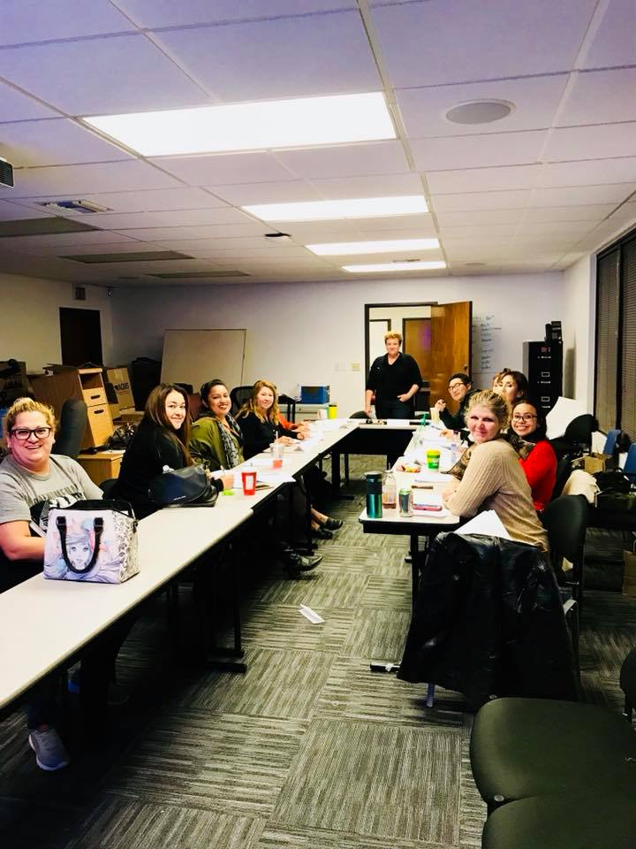

Goal #3: Improve the way we provide services so the people we support have better lives.

- Make sure the way we plan with each individual helps them to have a better life.
- Make sure plans help people to build relationships and have social opportunities.
- Make sure plans look at how technology might help the person.
- Make sure each person has the best way to communicate and that people are listening to them, especially about how they want to live their lives.
- Make sure that people have opportunities to earn income in ways that work for them.
- Help people to think about what happens when they or their parents get older.
- Help people to find affordable housing.

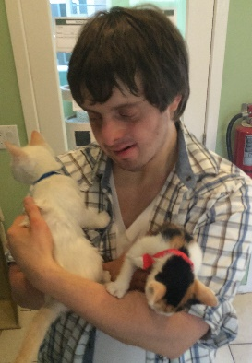

Goal #4: Help JNCS to be seen as a great agency who is good at helping the people we support and helping the system to get better.

- Get more involved in local, state, and national efforts to improve the lives of people with disabilities.
- Create more partnerships with community groups and businesses.
- Figure out good ways to use social media and other resources to let people know about JNCS.
- Help JNCS to make good decisions about how to grow our agency.

